# **Rotimi Ishola**

**MILESTONE 3: CONDUCTING A CONTENT AUDIT AND TECHNICAL REVIEW**

**PART 1: Competitive Content Analysis**

Click the link to see the research work**:**

[**https://1drv.ms/x/s!AtI6wJbrV6AjhBQqGa9fUCVupvdB?e=EoLBfJ**](https://1drv.ms/x/s!AtI6wJbrV6AjhBQqGa9fUCVupvdB?e=EoLBfJ)

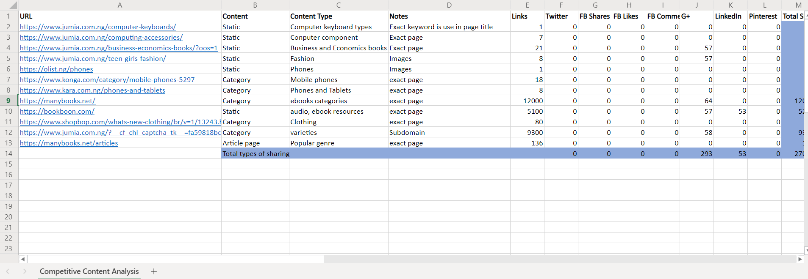

After the research of the competitive analysis, I realize that the content used is in categories and a lot of social sharing through more on Google plus which translate into different links, for example, on social sharing used by one of the competitors, manybooks.net, the exact page of the link generates highest number of links, especially on social sharing Google plus, which eventually translate into many links. The vertical axis indicates type of social sharing used by the competitors and the horizontal axis indicates social shares and links amount. Also, the content that resonate with the customers is mostly pinnable images which should be placed on the exact page of the domain in order to generate links and site should incorporate more content on Google plus to get more engagements with the audience and eventually generate links. There should be articles and blogs on different pages of the site and should be link together for purpose of effective search and link sharing that can lead to high ranking on Google search. To crown it all, looking at the metrics above, the top competitor is likely to generate more links on the root domain due to blogs and engagements from other sites and engagements from the customers.

**PART 2: Conducting an Internal Content Audit**

Click the link to see the research work**:**

[**https://1drv.ms/x/s!AtI6wJbrV6AjhBQqGa9fUCVupvdB?e=IApb4t**](https://1drv.ms/x/s!AtI6wJbrV6AjhBQqGa9fUCVupvdB?e=IApb4t)

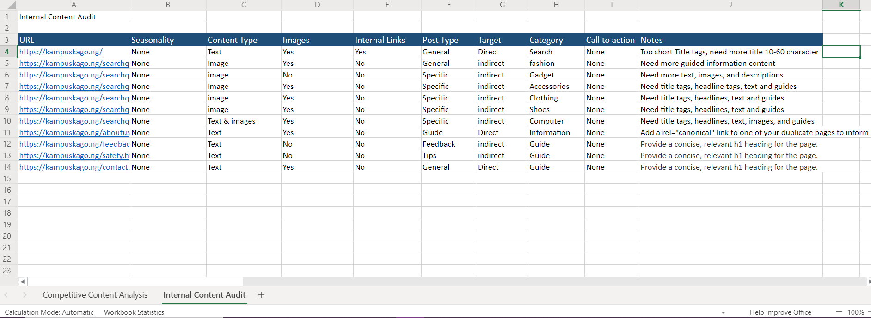

**Five and More New Content Ideas**

* Focus on getting links from Google plus.
* Optimize Title tags between 10 –60 characters.
* Create a section of content on blog.
* Create a content section on eBooks categories.
* Use more text and images to generate page authority.
* Use video to capture more of domain authority.
* Incorporation of right keywords for SEO optimization.
* Provision of a concise and relevant H1 heading for each page of the site.
* Use of Social media to generate links.

**PART 3: Creating a Keyword Map**

Click the link to see the research work**:**

[**https://1drv.ms/x/s!AtI6wJbrV6AjhBQqGa9fUCVupvdB?e=4dp4tz**](https://1drv.ms/x/s!AtI6wJbrV6AjhBQqGa9fUCVupvdB?e=4dp4tz)

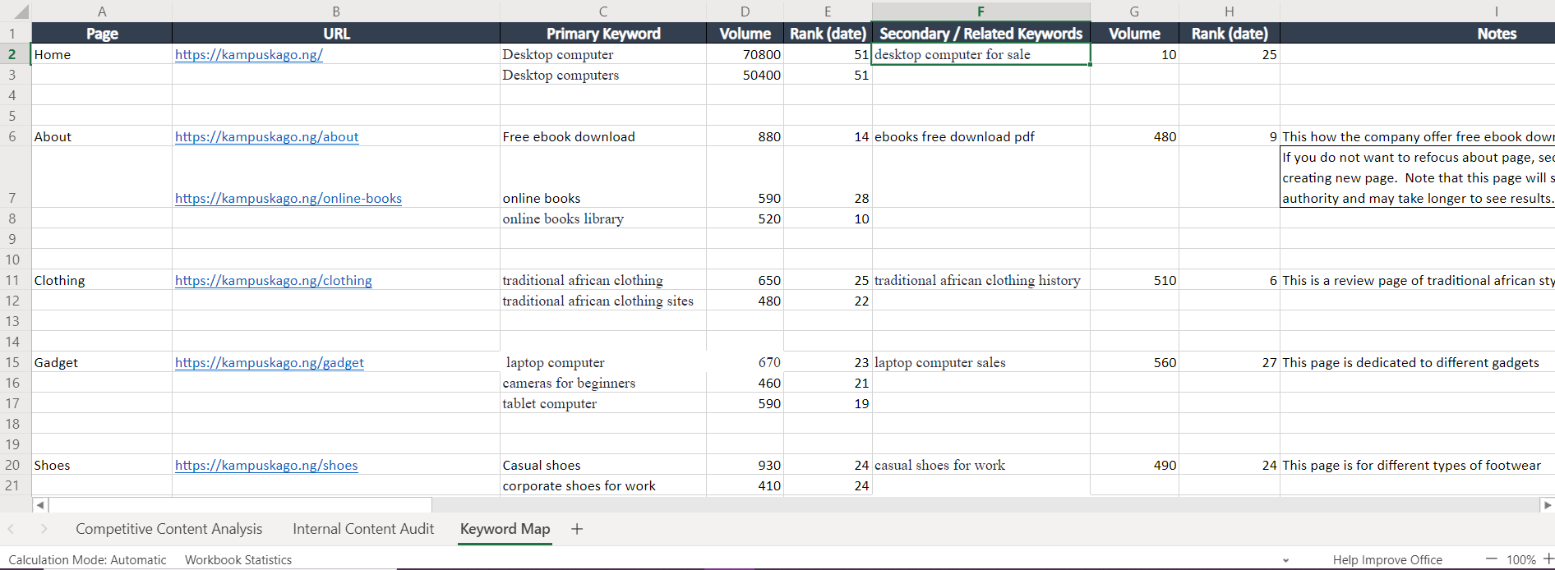

**PART 4: Analysing the Technical Factors**

There is no Robot.txt file on the website

**Recommendations for Robot.txt file:**

* To control Search Robot.
* Robot.txt file defines which areas of website crawlers are allowed to search.
* The web page will not be rank when Robot.txt file is disallowed.
* Before file is save to the root directory of the site, it is important to check the syntax because, any minor error can lead search bots disregarding the disallow rules and crawling website that should not index.

**Pages that Robot.txt do not crawl:**

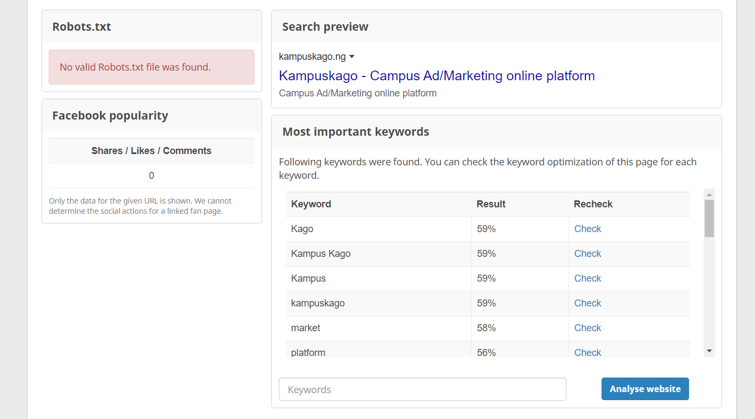

**Reasons:**

* **https://kampuskago.ng/Market:** Image SEO is not found in any alt attribute of an image, not found in any image URL, not used within the headings, and missing in the H1 heading. Because HTML content is not well optimized.
* **https://kampuskago.ng/Contact Us:** Missing Title tag and Meta Description is not within the first 120 characters because of fault in Meta attribute.
* **https://kampuskago.ng/Online Platform:** At the end within the title: **platform** (important keywords should be at the beginning. In Image SEO, not found in any alt attribute of an image: **Online, Platform,** not found in any image URL: **Online, Platform,** not found in an image title: **Online, Platform,** not in the page's text content: **online,** because of HTML is not Optimized.

The Existing Robot.txt file:

* **Domain**: Occurs in the domain: **Kampus, Kago.**
* **Stops Words:** None of the keywords is a known stop word.

Because the domain is containing the main keyword and relevant for SEO and online marketing.

Yes, there are 101 errors after site audit.

Click the link to see the Error research work**:**

[**https://1drv.ms/x/s!AtI6wJbrV6AjhBQqGa9fUCVupvdB?e=4bzrOS**](https://1drv.ms/x/s!AtI6wJbrV6AjhBQqGa9fUCVupvdB?e=4bzrOS)

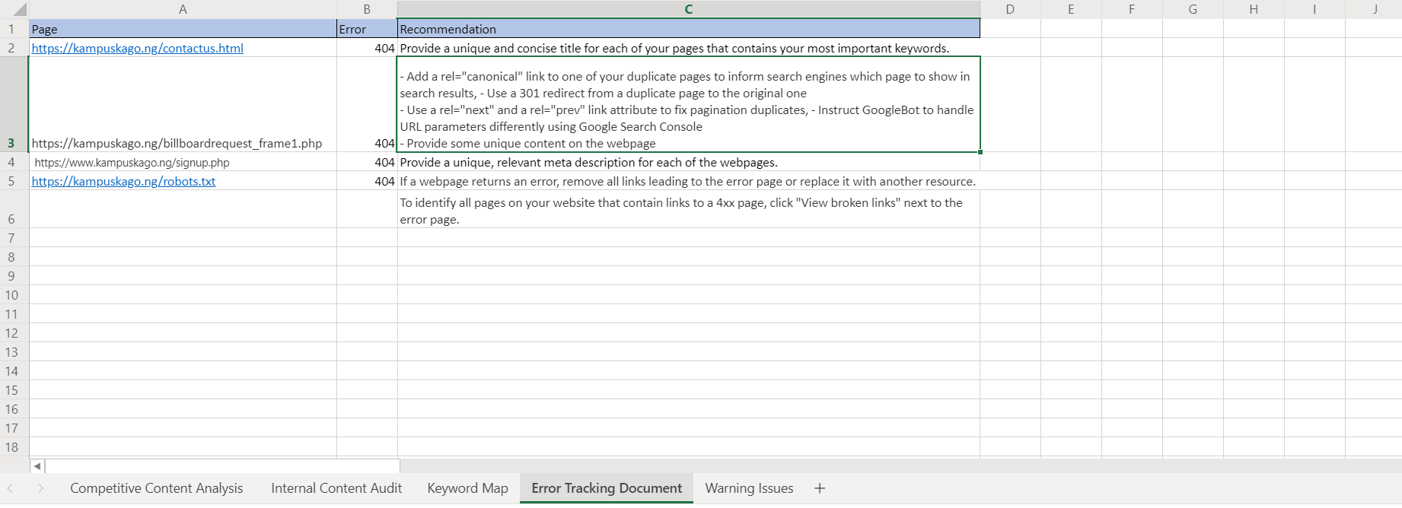

Click the link to see the Improper redirect research work**:**

[**https://1drv.ms/x/s!AtI6wJbrV6AjhBQqGa9fUCVupvdB?e=kfeVz6**](https://1drv.ms/x/s!AtI6wJbrV6AjhBQqGa9fUCVupvdB?e=kfeVz6)

